MY SQL & Mongo DB
Prerequisites
- Tools: MySQL Server 8.0+, MySQL Workbench (GUI), and Command Prompt (CLI), Mongo DB Server Community Edition with Mongo Compass (GUI), mongosh(CLI)
- Sample Database: We will build a simple HR_Management system (Employees, Departments, Salaries) throughout the course.

Day 1: SQL Language Core & Data Manipulation

Data – Set of Related Information.
Database – Is a Structured/organised way of managing the data. (CRUD)
Database Entities – Table, Query, View, Cursor, Function, Stored Procedure, Trigger, Sequence, Materialized View.
Table – Is a primary SQL Entity used to manage the data in a row & column format. (Fixed schema data manager)
Row & Column = Records and Fields.
DBMS – Data Base Management System – It’s a Software which will help to manage the Database related operations.
RDBMS – Relational DBMS – MySQL, Oracle, MS-SQL, Postgres, DB2 etc., (SQL based)
SQL – Structured Query Language. (Lang of RDBMS)
Store it in Flat file (.txt, .rtf, .csv, .doc etc.,)

Abcd, abcd@gmail.com 9867452312 64,II St, Adayar, Chennai. 6787 7687 8798

Focus: Mastering the syntax (DDL, DML, DQL, TCL) and using built-in tools to manipulate data.
My SQL Architecture, DDL & Constraints
- CLI vs. GUI:
  - Logging in via terminal: mysql -u root -p
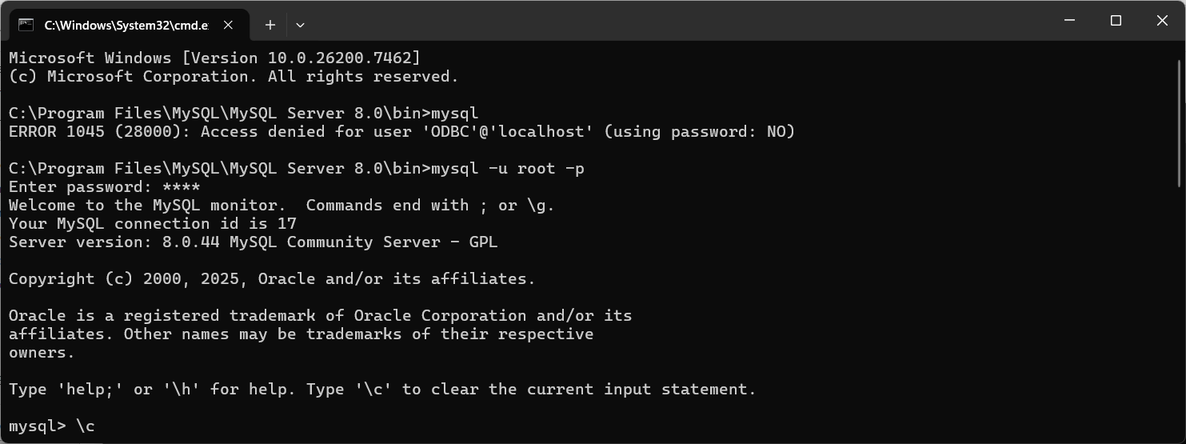
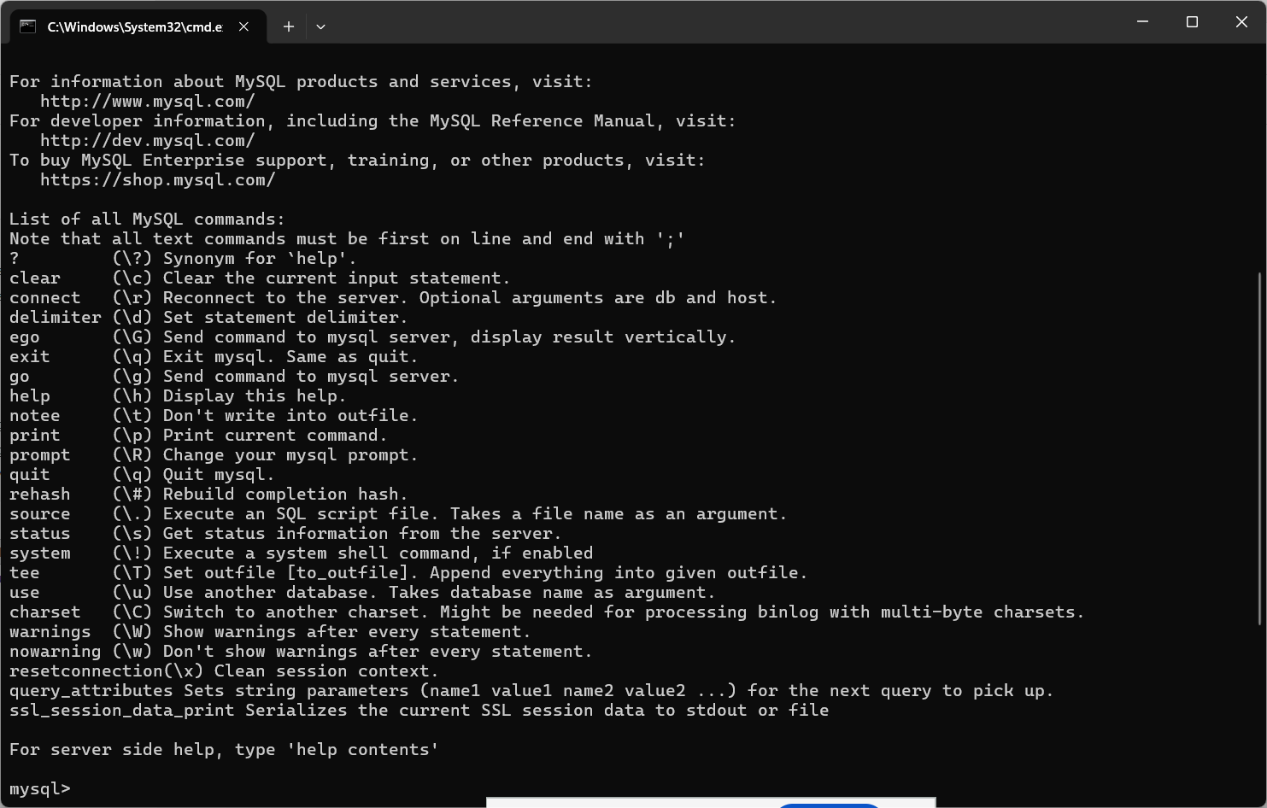
Show databases; - List all available databases in current schema.
Use <schema_name> - To use/connect to a particular schema/database.
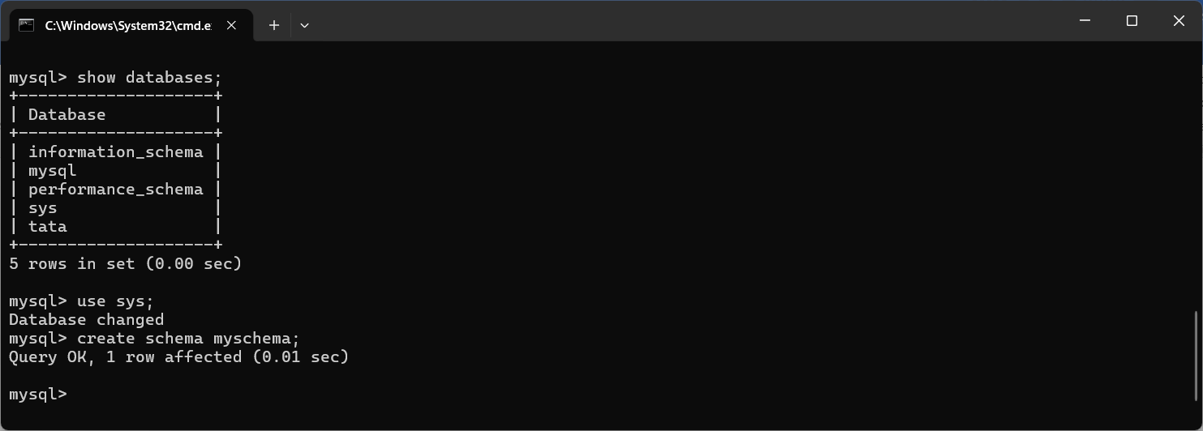
  - Navigating Workbench: Schemas vs. Administration tab.
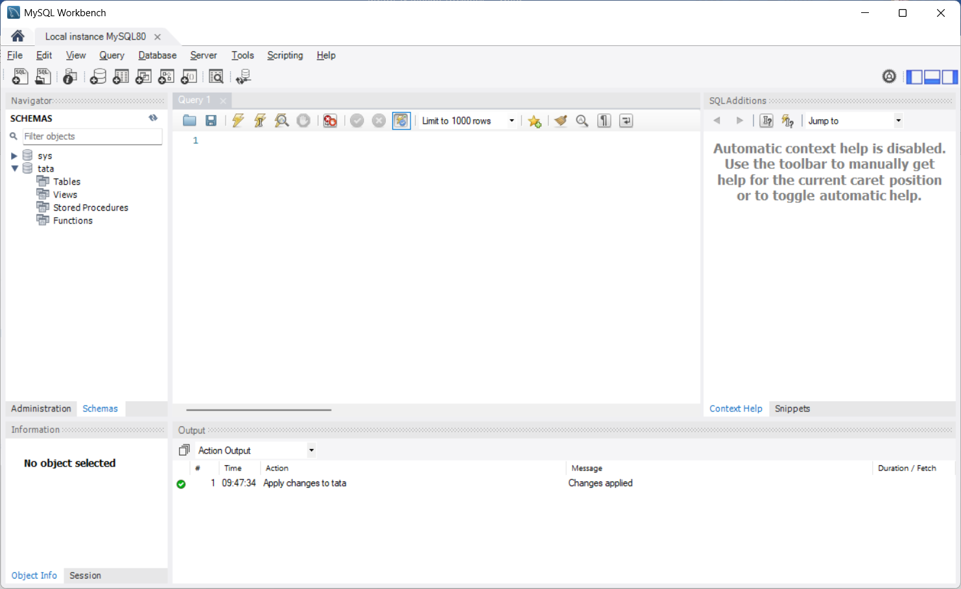
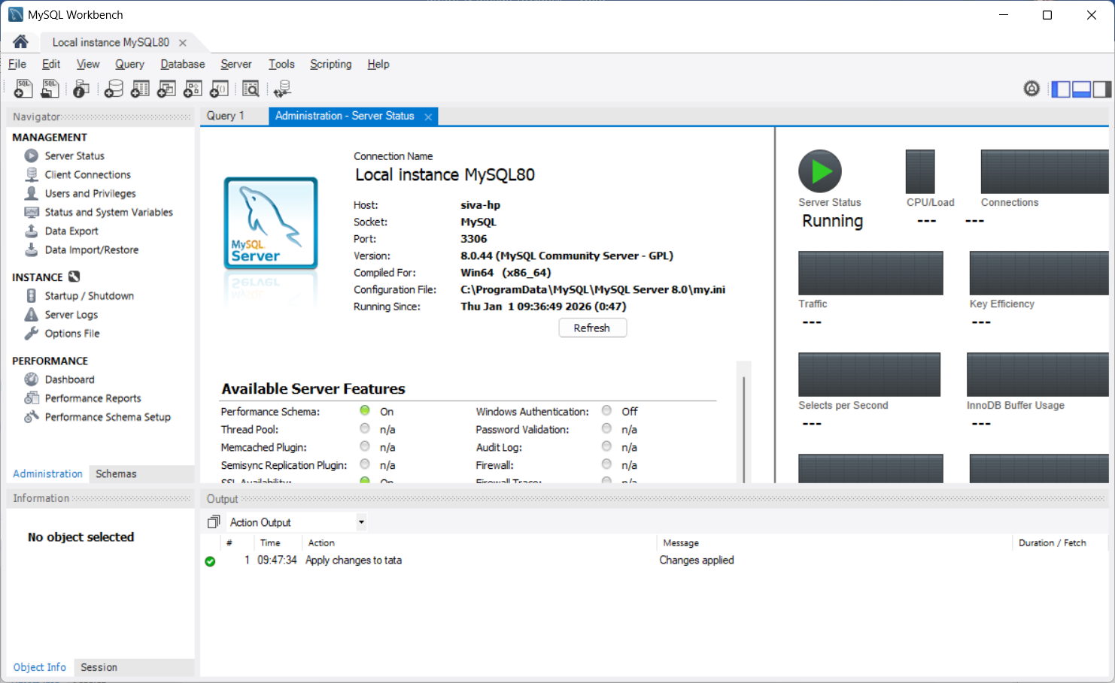

Basic Operations in DB – Read (returns data but wont make any changes to any entities) & Modify (It changes the Data – Add/update or edit /remove or delete)
SQL – DDL, DML, DCL, TCL, DQL
https://dev.mysql.com/doc/index-other.html
SET GLOBAL local_infile=1;
LOAD DATA LOCAL INFILE 'pet.txt' INTO TABLE pet;

LOB – Large Object (Max 2GB)

CRUD

INSERT INTO `tata`.`employee`
(`id`,
`name`,
`email`,
`mobile`,
`gender`)
VALUES
(<{id: }>,
<{name: }>,
<{email: }>,
<{mobile: 0}>,
<{gender: }>);

Full Insert with column names
INSERT INTO employee (id,name,email,mobile,gender) VALUES (<{id: }>,<{name: }>,<{email: }>,<{mobile: 0}>,<{gender: }>);

Full Insert without column names
INSERT INTO employee VALUES (<{id: }>,<{name: }>,<{email:} >,<{mobile: 0}>,<{gender: }>);

Partial Insert (Columns names are compulsory)
INSERT INTO employee (name,email,mobile) VALUES (<{name: }>,<{email: }>,<{mobile: 0}>);

UPDATE `tata`.`employee`
SET
`id` = <{id: }>,
`name` = <{name: }>,
`email` = <{email: }>,
`mobile` = <{mobile: 0}>,
`gender` = <{gender: }>
WHERE `id` = <{expr}>;

UPDATE employee SET `name` = <{name: }>,`email` = <{email: }>,`mobile` = <{mobile: 0}>,
`gender` = <{gender: }> WHERE `id` = <{expr}>;

DELETE FROM employee where id=<{id:}>;

SELECT * from employee; -- Simple select or Full Select (Read)
SELECT * from employee limit 100; -- selecting first 100 records

CREATE TABLE `tata`.`employee` (
`id` INT NOT NULL AUTO_INCREMENT,
`name` VARCHAR(255) NOT NULL,
`email` VARCHAR(255) NOT NULL,
`mobile` BIGINT(10) NULL DEFAULT 0,
`gender` CHAR(1) NULL,
PRIMARY KEY (`id`),
UNIQUE INDEX `email_UNIQUE` (`email` ASC) VISIBLE);

Audit Column -- createdAt & by, updatedAt & by
Constraints -
- DDL (Data Definition Language):
  - CREATE, ALTER, DROP, TRUNCATE.
  - Data Types: INT, VARCHAR, DECIMAL, DATE, ENUM.
- Constraints (The Rules):
  - Domain Integrity: NOT NULL, CHECK (e.g., salary > 0).
  - Entity Integrity: PRIMARY KEY, AUTO_INCREMENT.
  - Referential Integrity: FOREIGN KEY (Linking Tables).
DML, DQL & CRUD Operations
- DML (Data Manipulation Language):
  - INSERT (Bulk vs Single), UPDATE (Safe mode precautions), DELETE.
- DQL (Data Query Language):
  - The SELECT anatomy.
  - Filtering: WHERE, LIKE, IN, BETWEEN.
  - Sorting: ORDER BY (ASC/DESC).
  - Limiting: LIMIT & OFFSET (Pagination basics).
CREATE TABLE `tata`.`department` (
`id` INT NOT NULL AUTO_INCREMENT,
`dept_name` VARCHAR(75) NOT NULL,
`manager_id` INT NOT NULL,
PRIMARY KEY (`id`),
UNIQUE INDEX `dept_name_UNIQUE` (`dept_name` ASC) VISIBLE,
INDEX `dept_fkey_idx` (`manager_id` ASC) VISIBLE,
CONSTRAINT `dept_fkey`
FOREIGN KEY (`manager_id`)
REFERENCES `tata`.`employee` (`id`)
ON DELETE NO ACTION
ON UPDATE NO ACTION);

- Lab 1: Create Employees and Departments tables via CLI, then populate them using Workbench (GUI).
Row-Level vs. Column-Level Functions
- Row-Level (Scalar) Functions: Operate on a single record.
  - String: CONCAT(), SUBSTRING(), UPPER(), LENGTH().
  - Date: NOW(), DATEDIFF(), DATE_FORMAT().
  - Logic: IFNULL(), COALESCE().
- Column-Level (Aggregate) Functions: Operate on a group of records.
  - SUM(), AVG(), COUNT(), MIN(), MAX().
  - Grouping: The critical GROUP BY and filtering groups with HAVING (vs WHERE).
TCL & Transaction Safety
- TCL (Transaction Control Language):
  - The concept of a "Unit of Work."
  - START TRANSACTION (or BEGIN).
  - COMMIT (Save permanently).
  - ROLLBACK (Undo mistakes).
  - SAVEPOINT (Partial rollbacks).
- Lab 2: Simulate a salary transfer where the system crashes halfway (Rollback), then a successful transfer (Commit).

Day 2: Advanced Logic, Automation & Performance
Focus: Programming the database (Procedures/Triggers) and optimizing for speed (Indexing/Locking).
Sub-Queries & Complex Retrieval
- Sub-Queries (Nested Queries):
  - Scalar Sub-query: "Find employees earning more than the average salary" (Sub-query returns one number).
  - Table Sub-query: Using a sub-query in the FROM clause (Derived Tables).
  - Correlated Sub-queries: Queries that depend on the outer row (Logic loop).
  - EXISTS vs IN operators.
Programmable Objects (Procedures & Functions)
- Stored Procedures:
  - Why use them? (Security, Network traffic reduction).
  - Parameters: IN (Input), OUT (Return values), INOUT.
  - Logic inside SQL: IF/ELSE, CASE, WHILE loops.
- User Defined Functions (UDF):
  - Creating reusable logic (e.g., CalculateTax(salary)).
  - Difference: Functions must return a value; Procedures can return result sets.
Triggers & Locking Mechanisms
- Triggers (Automation):
  - BEFORE vs. AFTER events.
  - INSERT, UPDATE, DELETE events.
  - Use Case: Creating an Audit_Log table that automatically records who changed an employee's salary.
- Locking Strategies:
  - Shared Lock (Read Lock): "I am reading, please don't change this."
  - Exclusive Lock (Write Lock): "I am changing this, nobody else touch it."
  - Deadlocks: When two transactions block each other.
Indexing & Performance Tuning
- Indexing Architecture:
  - How B-Trees work (Root, Branch, Leaf nodes).
  - Clustered Index: The Primary Key (Data sorted physically).
  - Non-Clustered (Secondary) Index: Like a book index pointing to the page.
- Query Optimization:
  - Using EXPLAIN to see if your query hits an index or does a "Full Table Scan" (Bad!).
  - Cardinality: Why indexing "Gender" (Low cardinality) is usually useless.
- Final Lab: Create a "Slow Query" with 100k rows, then add an Index to make it instant.

Quick Concept Cheat Sheet
Concept | Description | Example SQL
DDL | Define Structure | CREATE TABLE User (...)
DML | Manage Data | INSERT INTO User VALUES (...)
DQL | Ask Questions | SELECT * FROM User
TCL | Manage Transactions | COMMIT;
Row Function | 1 Input to 1 Output | UPPER(name)
Column Function | Many Inputs to 1 Output | SUM(salary)

Day 3: The Transition – Mapping SQL to MongoDB
Focus: Translating Tables to Collections, and SQL Logic to MongoDB Aggregations.
Architecture & Comparison
- SQL vs. NoSQL Paradigm:
  - MySQL: Rigid Schema (Table $\to$ Row $\to$ Column).
  - MongoDB: Flexible Schema (Collection $\to$ Document $\to$ Field).
- BSON Data Types: Why MongoDB uses "Binary JSON" (support for Dates, Int64, etc.).
- Environment Setup: Connecting via Mongosh (CLI) and MongoDB Compass (GUI).
CRUD Operations (CLI & GUI)
- Insert: insertOne() / insertMany() vs. INSERT INTO.
- Find (Select):
  - Equality: { status: "A" } vs WHERE status = 'A'.
  - Logical Operators: $or, $and, $not.
  - Comparison: $gt (>), $lt (<), $ne (!=).
- Update: $set (update specific fields), $unset (remove column equivalent), $inc (increment counter).
- Delete: deleteOne(), deleteMany().
"Row & Column" Functions & Built-in Logic
- Row-Level Functions (Projections):
  - SQL: SELECT UPPER(name), price * 2 FROM products
  - Mongo: $project stage with $toUpper and $multiply.
- Column-Level Functions (Grouping):
  - SQL: SUM(), AVG(), COUNT()
  - Mongo: $group stage with $sum, $avg.
- Constraints (Schema Validation):
  - MongoDB is flexible, but you can enforce rules using JSON Schema Validation (e.g., "Email must be a string and required").
ACID Transactions & Joins
- ACID in MongoDB:
  - History: Single-document ACID was always there.
  - Modern: Multi-document ACID transactions (Start Session Start Transaction Commit). Note: Performance impact compared to MySQL.
- Joins ($lookup):
  - How to perform LEFT OUTER JOIN in MongoDB using the Aggregation Pipeline.
  - Lab: Join an Orders collection with a Products collection to see item details in the order.

Day 4: Advanced Logic, Optimization & Scaling
Focus: Replacing Stored Procedures, heavy Optimization, and handling massive scale.
Stored Procedures & Triggers (The Mongo Way)
- Stored Procedures Aggregation Pipelines:
  - Myth: "MongoDB uses stored JS." Reality: db.eval() is deprecated.
  - Solution: Complex logic is handled via Aggregation Pipelines (a series of processing stages) or Application Logic.
- Functions Aggregation Operators: Using $cond (If/Else), $switch, and $map to transform arrays.
- Triggers Change Streams:
  - Instead of database triggers, MongoDB uses Change Streams to push real-time notifications to your app when data changes.
Indexing & Query Optimization
- Index Types:
  - Single Field vs. Compound Index (and the importance of order).
  - Multikey Index (Indexing arrays).
  - Text Index (Search).
- The ESR Rule: Equality, Sort, Range. The golden rule for ordering your index keys.
- Profiling:
  - Using .explain("executionStats") to spot "Collection Scans" (The full table scan equivalent).
Replication (High Availability)
- Replica Sets:
  - Primary Node: Handles all writes.
  - Secondary Nodes: Replicate data for safety.
  - Automatic Failover: What happens if the Primary crashes? (Election process).
- Read Preference: Offloading read traffic to Secondary nodes (Eventual Consistency).
Scaling (Sharding) & Final Comparison
- Sharding (Horizontal Scaling):
  - Splitting data across multiple servers when it gets too big for one.
  - Shard Key: The most critical decision (Hashed vs. Ranged).
- Final Comparison Matrix:
  - Summary of when to stick with MySQL (Complex relational transactions) vs. Moving to MongoDB (High volume, flexible data, rapid iteration).
Concept Mapping Cheat Sheet
SQL Concept | MongoDB Equivalent | Notes
Row | Document | BSON format (Binary JSON).
Column | Field | Dynamic; not all docs need the same fields.
Join | $lookup | Used in Aggregation; heavier than SQL joins.
Stored Proc | Aggregation Pipeline | db.eval is dead; use Pipelines.
Trigger | Change Stream | Real-time event listening.
Constraint | Schema Validation | JSON Schema rules applied to collection.
GROUP BY | $group | Part of the Aggregation Framework.

